|  |
| --- |
| CiviCRM Custom Report – Installation Manual  **for Nubay Services** |
| Prepared by  Rajesh |
| Date  **27 January 2014** |

Contents

Installation: 2

Step 1: Create extension directory 2

Step 2: Install the report template extension. 2

Create Report Instance: 3

Step 1: Create the report instance from report template. 3

# Installation:

## Step 1: Create extension directory

If extensions directory is not setup already, create and set your extensions directory in CiviCRM at:

<http://example.com/civicrm/admin/setting/path?reset=1>

See below URL for full instructions and information on how to set and configure extensions:

<http://wiki.civicrm.org/confluence/display/CRMDOC/Extensions>

## Step 2: Install the report template extension.

1. Uncompress the attached file. (org.nubay.contributionsovercertaintotalamount.zip)

2. Copy 'org.nubay.contributionsovercertaintotalamount' directory to the extension directory.

3. Navigate to CiviCRM Navigation Menu >> Administer >> System Settings >> Manage Extension.

NOTE: Click refresh button in the bottom of the page, if you can’t see the new extension listed there.

4. Install the extension.

# Create Report Instance:

## Step 1: Create the report instance from report template.

1. Navigate to CiviCRM Navigation Menu >> Administer >> CiviReport >> Create New Report from Template.
2. Click ‘Contributions Over Certain Total Amount (org.nubay.contributionsovercertaintotalamount)’ link under ‘Contribution Report Templates’ subsection.
3. This will take you to the report template, which was created as extension. Review the filters and click ‘Preview Report’ button.

Along with selecting the criteria for amount greater than $xxx, you can also choose other options like less than, in between, etc. See screen show below.

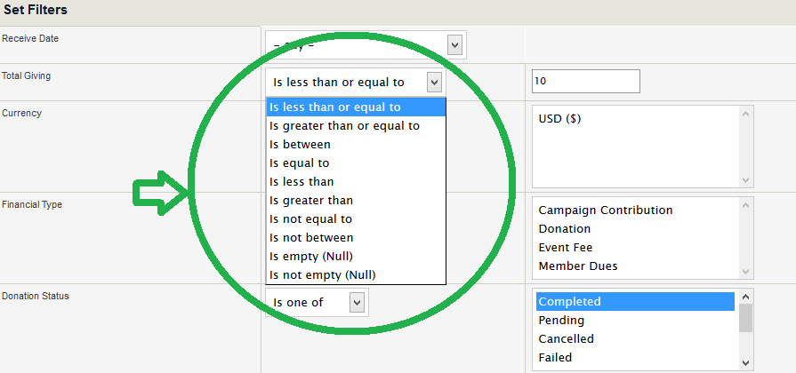

1. Now you should be able to see the results in the report, if data is available in the CiviCRM instance.
2. Under ‘Create Report’ section
   1. Please specify a report title. Example: Contributions Over Certain Total Amount
   2. Click ‘Include Report in Navigation Menu?’ checkbox, if you want to include the report instance link in the Navigation menu and select the parent menu. (Optional)

Example: Select ‘Contribution’ in Parent Menu dropdown, if you want to include the report link under CiviCRM Navigation Menu >> Contributions.

* 1. Set permissions, ACL Group/Role, if necessary. (Optional)
  2. Reserve the report & make it available in dashboard, if necessary. (Optional)
  3. Click ‘Create Report’ button

1. Now you should be able to access the report from CiviCRM Navigation Menu >> Contribution >> Contributions Over Certain Total Amount, if examples from above Point No. 5a , 5b are used.